Staff Sergeant William Laffin
Company B, 1st Battalion, 116th Infantry Regiment, 29th Infantry Division
Omaha Beach

1930 Census
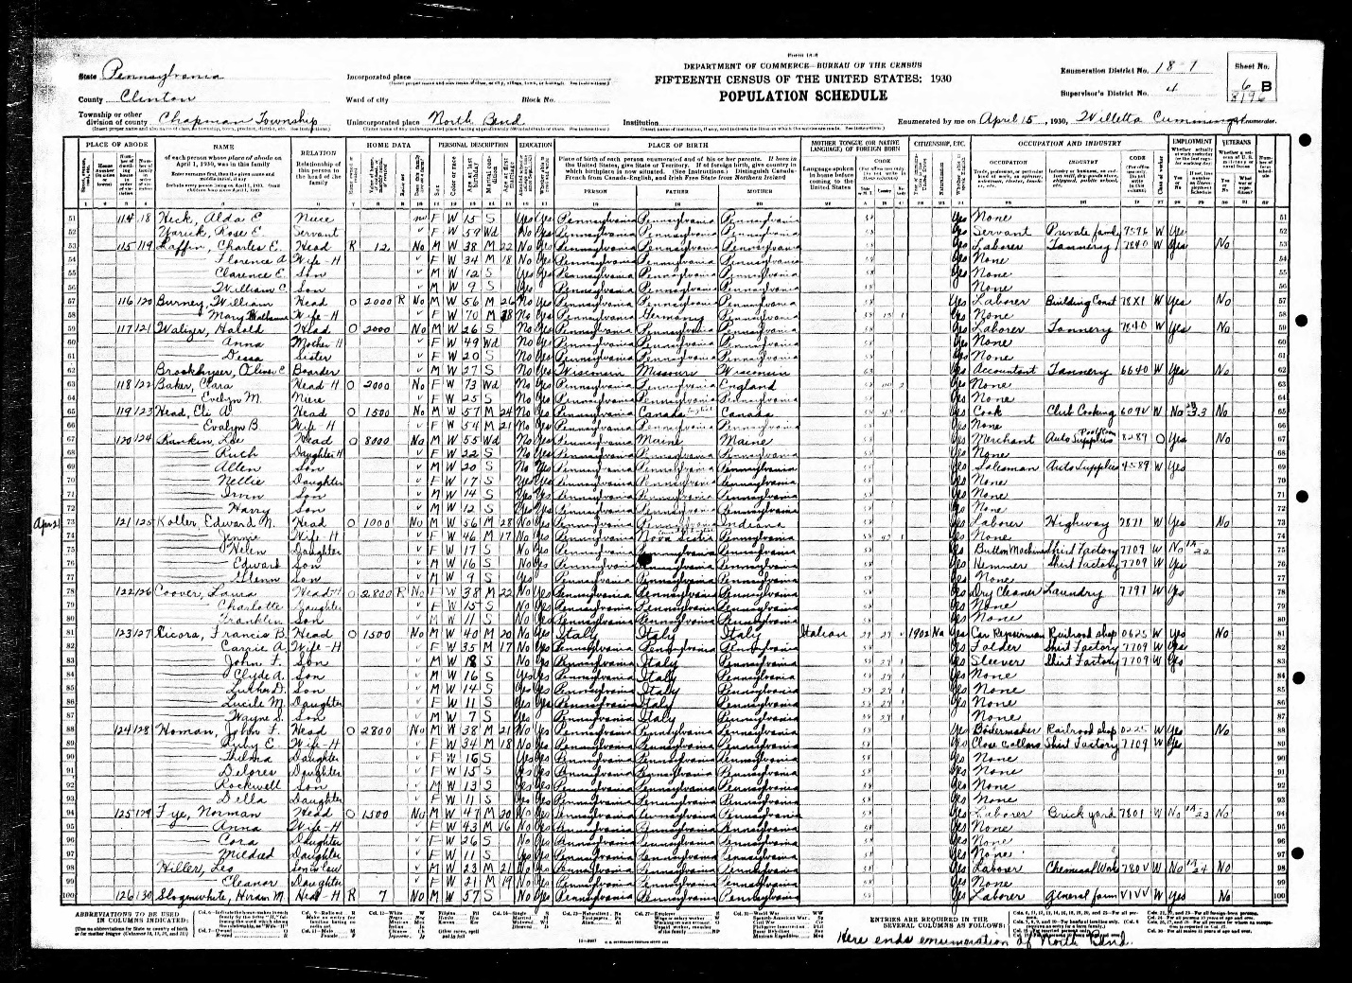

Draft Registration Card
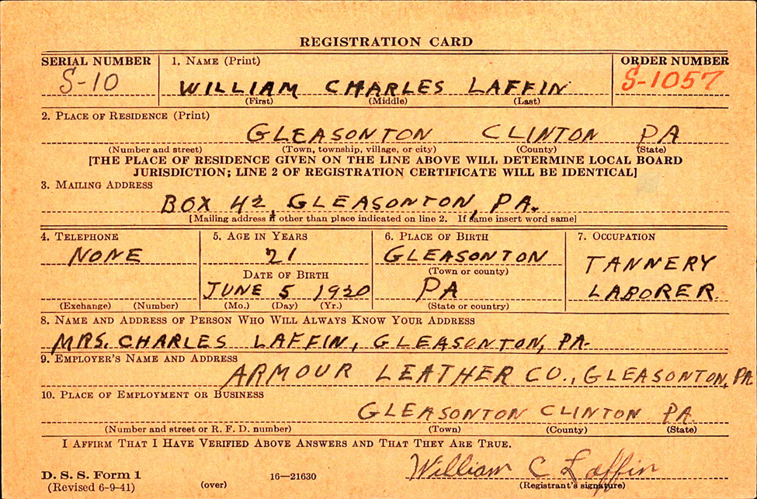
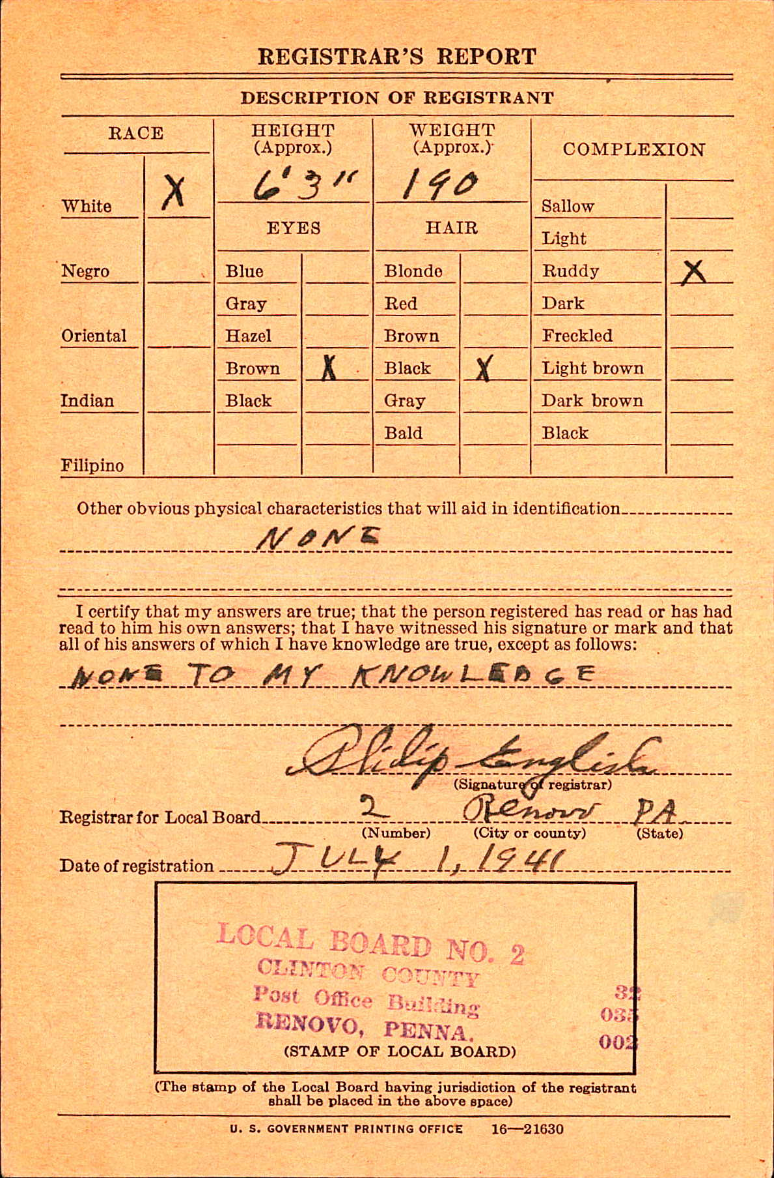
Pension File
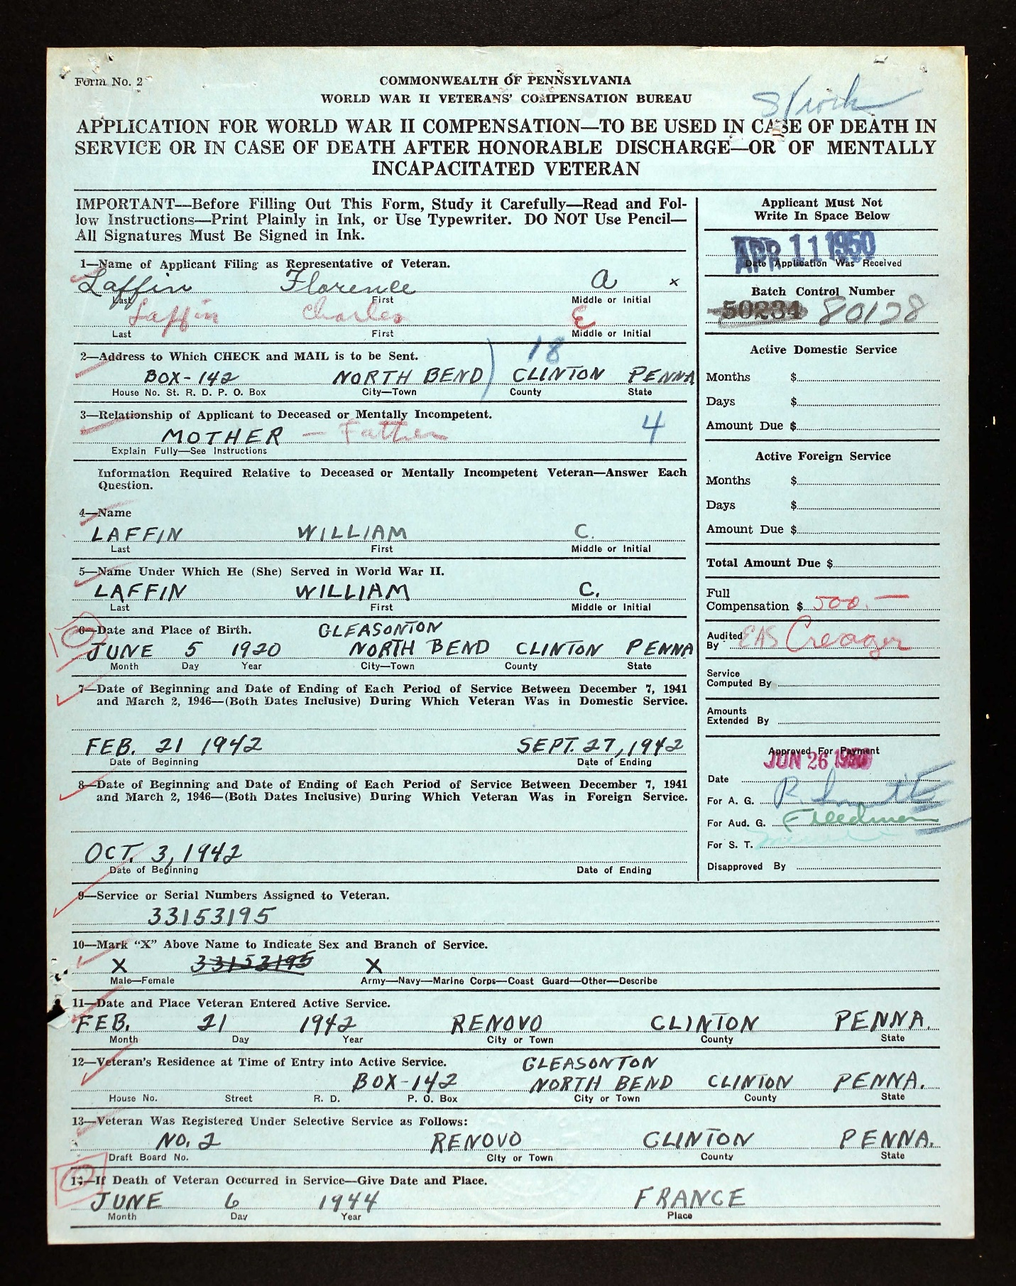
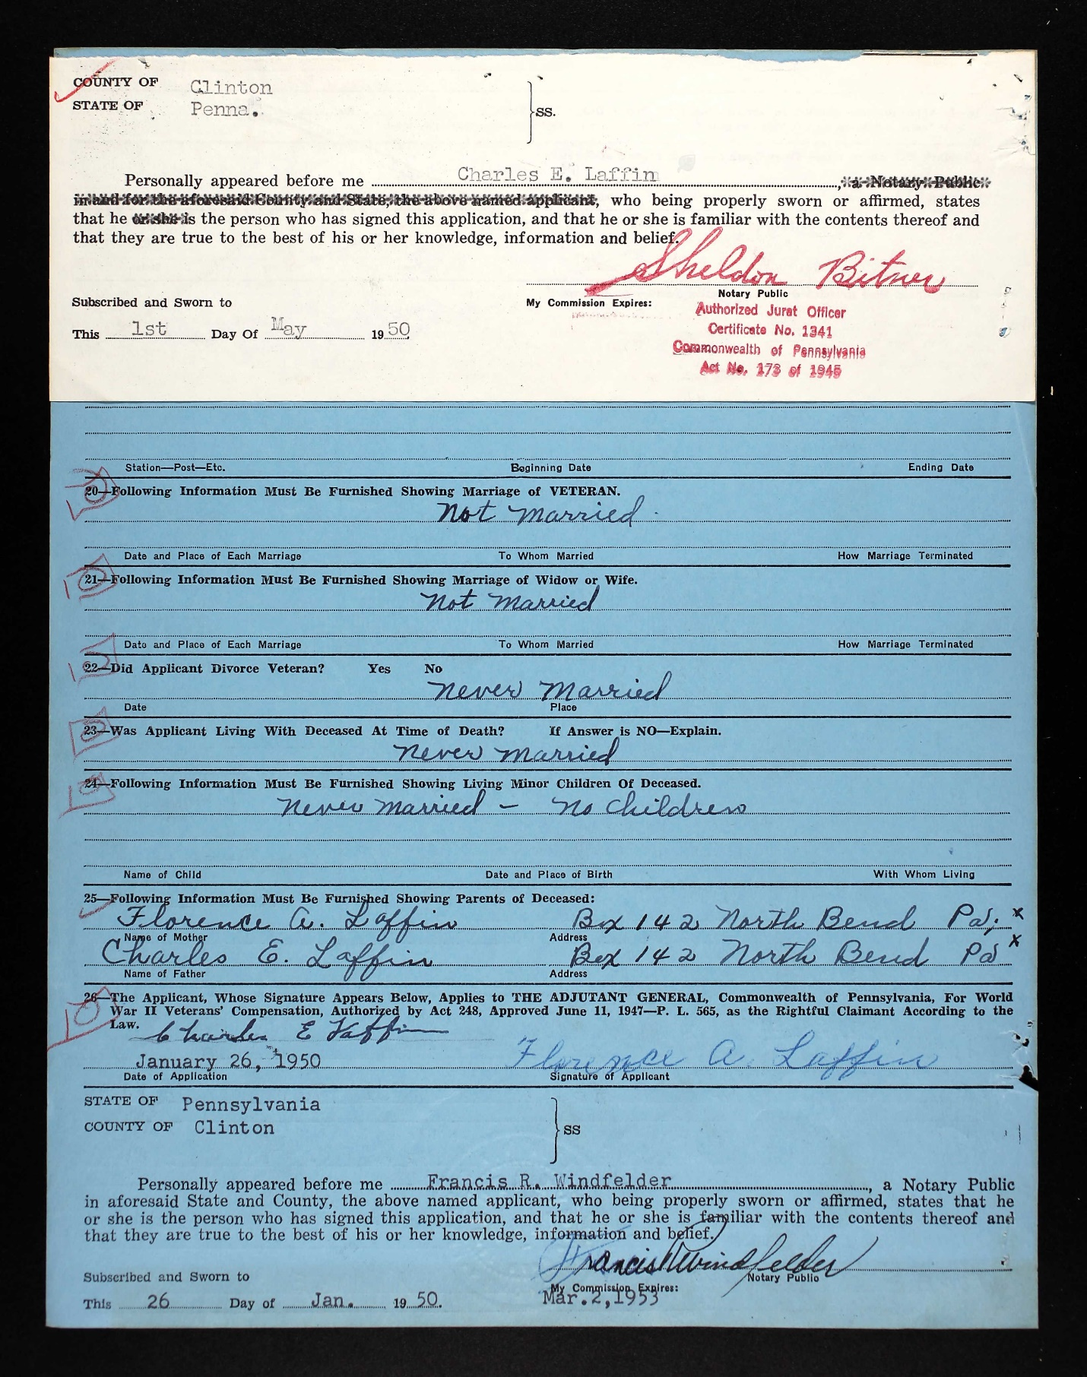

The Lock Haven Express, Lock Haven, PA
July 18, 1944
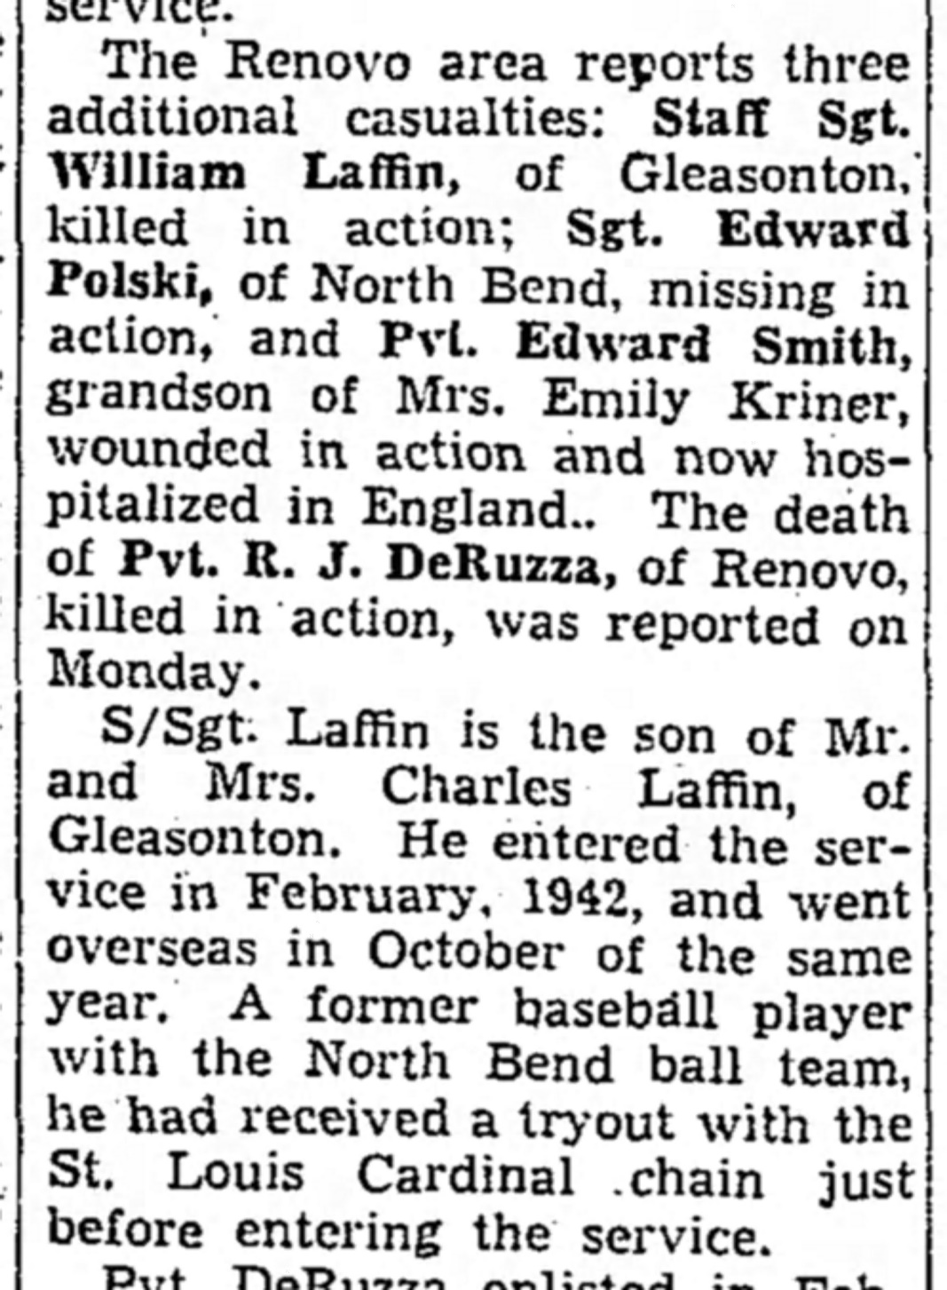

Lock Haven Express, November 24, 1947

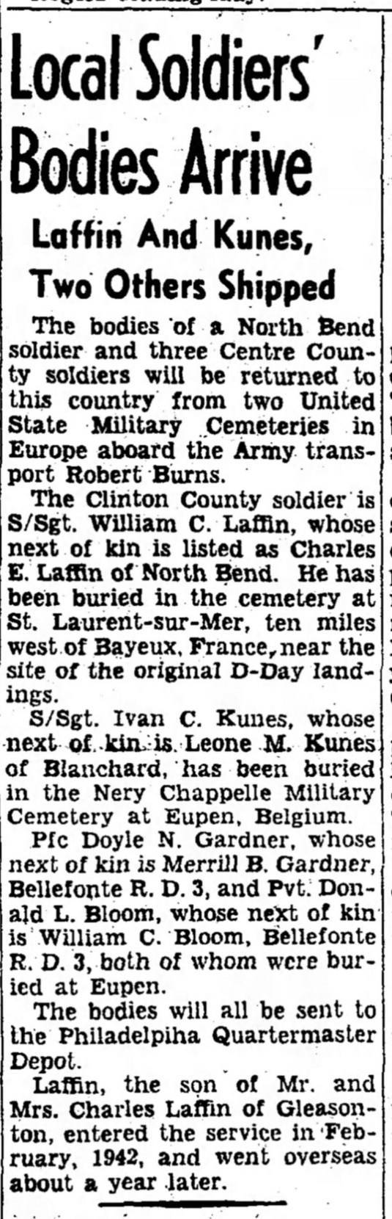

National Cemetery Interment Form
